**Pushing Cloudwatch logs to S3 bucket using Event bridge and Lambda function**

Create an S3 bucket for pushing the CW logs .

Create a lambda function to push the CW logs to S3 bucket.

Navigate to Lambda and create function

Select create from scratch and give name and select the programming language

Here we are using Python 3.10

Once the function is created we see like this:

Paste the Python code under Code and click on Deploy.

Give the name of the S3 bucket and prefix to store the logs , and logs paths from CW logs .

Click on Test to test code.

Set the Timeout to 5 mins

Give the Lambda function permission for Cloudwatch , click on the role and give permission.

Navigate to AWS Eventbridge and select EventBridge Schedule

Give the name for schedule , create schedule group from same console or use default group and select recurring

Provide the schedule plan

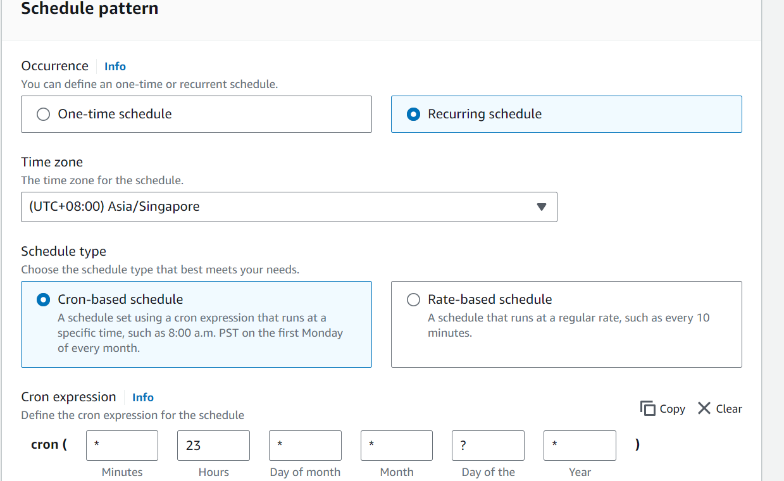

Click next and select target as Lambda function

Select the Lambda function created

Rest choose the default options and create schedule.